

Maraton

Genomics Distribution Computing System

October 22, 2015

YHGenomics

Contents

1. Third-part Library 2

1.1. Libuv 2

1.1.1. Description 2

1.1.2. Usage 2

1.1.3. API 2

1.2. Json 3

2. UML Diagram 3

3. Interface Layout 4

3.1. Singleton<T> 4

3.1.1. static instance() 4

3.2. Manager<T> 4

3.2.1. void push(T* instance) 4

3.2.2. bool pop(T* instance) 4

4. Protocol Layout 4

5. Utility 4

5.1. CircleBuffer 5

5.1.1. push(const char* data, int len) 5

5.1.2. char* pop(int len) 5

5.2. Buffer 5

5.2.1. Buffer(const Buffer& buffer) 5

5.2.2. Buffer(const Buffer&& buffer) 5

5.2.3. Buffer& operator=(Buffer& buffer) 5

5.2.4. Buffer& operator=(Buffer&& buffer) 5

5.2.5. raw(const char* data,int len) 5

5.2.6. char* raw() 6

5.2.7. int length() 6

5.3. Logger 6

5.3.1. static void sys(const char* fmt,…) 6

5.3.2. static void error(const char* fmd,…) 6

5.4. Zlib 6

5.4.1. Buffer compress(const char* data,int len) 6

5.4.2. Buffer uncompress(const char* data , int len) 6

5.5. UUID 7

5.5.1. static string create() 7

6. Network Layout 7

6.1. Network Layout 7

6.1.1. UVSockService 7

6.1.2. SessionManager<TT> 8

6.1.3. Session 9

6.1.4. HTTPSession 9

6.1.5. ClusterSession 9

6.1.6. ExecutorSession 10

6.1.7. MasterSession 10

6.2. HTTP Protocol Layout 10

6.2.1. HTTPHandler 10

6.2.2. HTTPRouter 11

6.2.3. HTTPRequest 11

6.2.4. HTTPResponse 12

7. Master Layout 13

7.1. Executor 13

7.2. ExecutorManager 13

8. Executor Layout 13

8.1. Master Session 13

# Third-part Library

## Libuv

http://libuv.org/

### Description

libuv is a multi-platform support library with a focus on asynchronous I/O

### Usage

### API

#### uv_tcp_init(uv_loop_t* loop,uv_tcp_t* tcp)

Initial a TCP socket

#### uv_ip4_addr(char* ip,sockaddr_in* sockaddr)

Initial a ipv4 address

#### uv_tcp_bind(uv_tcp_t* handle,const sockaddr* sock,uint flag)

Bind an address to a sock

#### uv_tcp_connect(uv_connect_t* conn,uv_tcp_t* tcp,sockaddr* sockaddr,uv_connect_cb cb)

Connect to a remote TCP server

## Json

Checkout http://nlohmann.github.io/json/

# UML Diagram

## Class Relation

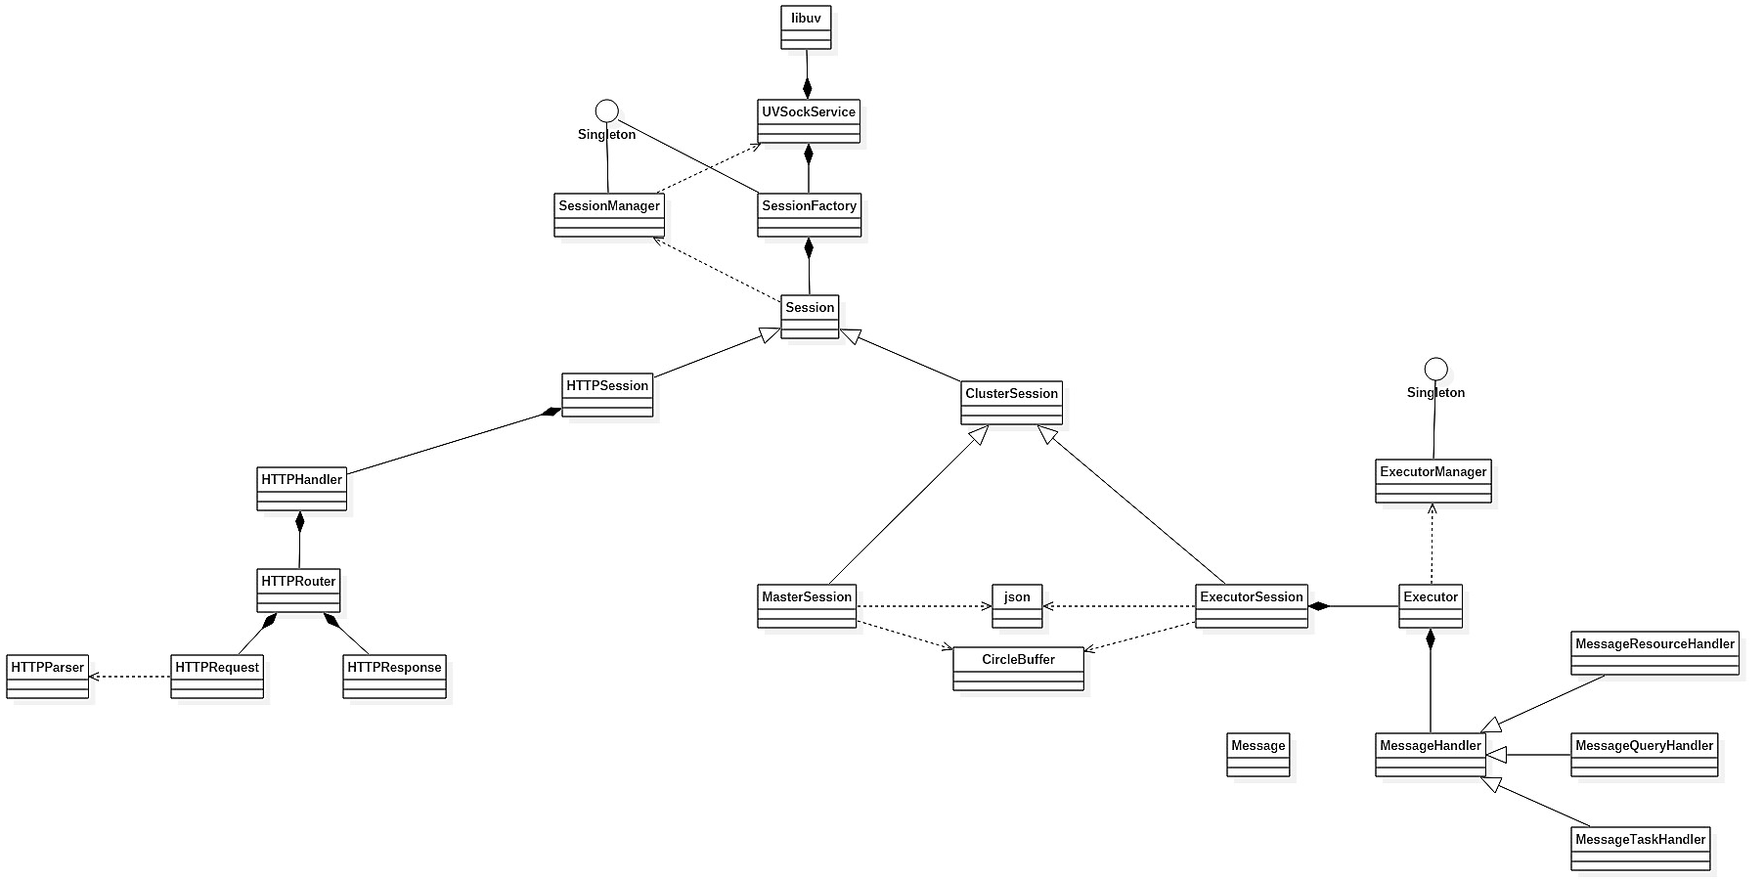

## Data Flow Diagram

### Connection Flow

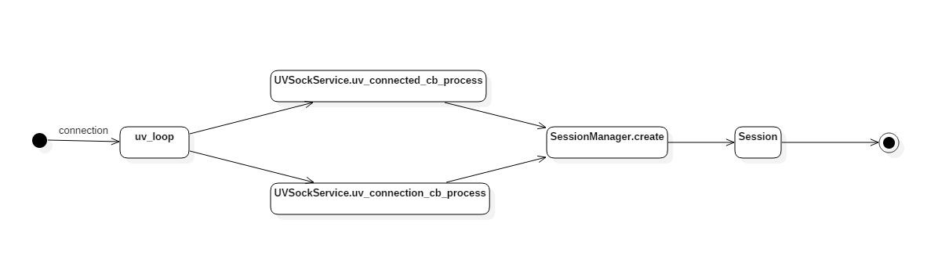

### Session Close Flow

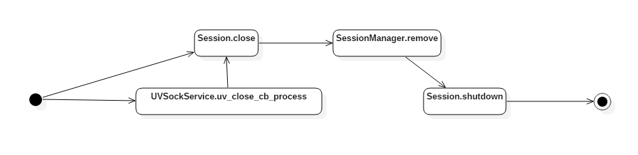

### Cluster Session Data Flow

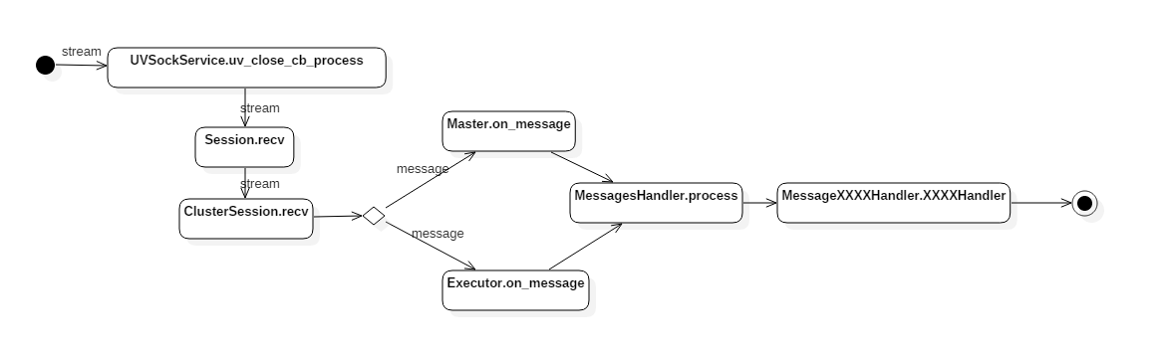

### HTTP Session Data Flow

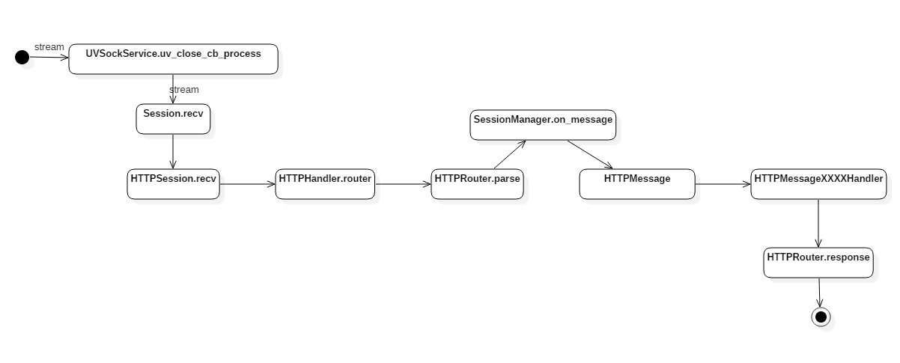

# Interface Layout

## Singleton<T>

Template class for making a singleton class.

Children classes must declare friend Singleton<T> in your private region.

### static instance()

Return the instance of class

## Manager<T>

Provide manager function

### void push(T* instance)

Add a new element to the set

### bool pop(T* instance)

Remove na element in the set

PS: This function will not free the memory

# Protocol Layout

# Utility

## CircleBuffer

Provide a circle-buffer for saving memory.

### push(const char* data, int len)

Add a data to the buffer

### char* pop(int len)

Remove and return the data with len length



## Buffer

Provide a memory data struct with data pointer and data length

### Buffer(const Buffer& buffer)

Copy construction

### Buffer(const Buffer&& buffer)

Move construction

### Buffer& operator=(Buffer& buffer)

Override operator

### Buffer& operator=(Buffer&& buffer)

Override operator

### raw(const char* data,int len)

Setter.

Set Buffer data and length

This function will copy the data and not release the input data.

### char* raw()

Getter.

Return the pointer of the data

### int length()

Getter

Return the data length

## Logger

Provide a logger function

### static void sys(const char* fmt,…)

Output the string in sys-format

### static void error(const char* fmd,…)

Output the string in error-format

## Zlib

Provide a crypt, decrypt, compress and decompress functions

### Buffer compress(const char* data,int len)

Compress the data.

This functions will copy data into Buffer and not release the input data

### Buffer uncompress(const char* data , int len)

Compress the data.

This functions will copy data into Buffer and not release the input data

## UUID

Make a UUID

### static string create()

Return a UUID string

# Network Layout

## Network Layout

### UVSockService

Main network class. Provide the basic function of network.

Receiving data

Connect to server

Accept client

Release Session

#### bool listen( std::string ip, int port );

Make socket in server mode, that will accept income connection

#### bool connect( std::string ip, int port );

Make socket in client mode, that will connect to the target server

#### void run();

Run the main loop

This function will block the thread, any logic, register must be set before

### SessionManager<TT>

Session manager, will manage all the session, splits sessions by class type (TT)

Provide functions to add, remove, find, callback

#### Parent Class

* Manager<T>
* Singleton<SessionManager<T>>

#### Custom Type

* std::function<void( TT* )> callback_t

#### TT* create(uv_tcp_t*)

Create a session by passing uv_tcp_t to it

#### bool remove(TT* t)

Remove the target session

#### TT* find( TT* t)

Find the target session by it instance.

If there is not such session it will return nullptr, otherwise return the instance.

#### void on_create(callback cb)

Callback when a new session was created

#### void on_close(callback cb)

Callback when a session was closed

### Session

Basic session class provide a way to use it

#### void close()

Close the session

This function will not effect immediately until next loop.

#### void send(const char* data,int len)

Send the data to socket

This function will not effect immediately until next loop.

### HTTPSession

HTTP protocol session, created by port 80.

#### Parent Class

* Session

#### HTTPHandler* handler();

Return the handler pointer

### ClusterSession

Basic class for cluster node.

Parse the network stream.

Verify the data

#### Parent Class

* Session

#### virtual send(Message* message)

Send the message to the remote

#### virtual on_message( callback )

Callback when a message is arrived

#### virtual on_close( callback )

Callback when the session was closed

### ExecutorSession

Provide functions to communicate with the target executor.

This class is only used for master mode.

#### Parent Class

* ClusterSession

### MasterSession

Provide functions to communicate with the master

This class is only used for executor mode.

#### Parent Class

* ClusterSession

## HTTP Protocol Layout

### HTTPHandler

Provide HTTP formatting function.

### HTTPRouter

Provide usages for routing the http request

#### void parse( const char* data, int len)

parse data and dispatch the request

#### response( callback )

Tell the class how to send data to client.

Callback when the class needs sending data to the client.

#### get(string path, callback)

Register a Get request on [path].

Callback when a GET request with the path arrived

Start with “/“

#### post(string path, callback)

Register a Post request on [path]

Callback when a POST request with the path arrived

### HTTPRequest

Manage the request, reads the HTTP header and body

#### string method()

Return the HTTP request mothod

#### string path()

Return the HTTP request path

#### map<string,string> header()

Return the HTTP header configuration

#### string body()

Return the HTTP body data

#### bool parse( const char data, size_t len )

Parse the data as an available HTTP request

If the request is a HTTP then return true, otherwise return false

### HTTPResponse

Provide functions to make response easier

#### void status(int status)

Set the response status

#### int status()

Return the status

#### void header(string name, string value)

Set the header

#### void content(string content)

Set the response content

#### int length()

Return the length of response content

#### Buffer bytes()

Return the Buffer for entire response

#### clear()

Reset the response. Cleanup

# Executor Layout

## Executor

## ExecutorManager

# Master Layout

## Master Session